Impact of Explicit Health Benefits Package on Support for Universal Health Care

Masters Thesis

Sean Duan

April 9, 2021

# Introduction

Universal Health Care (UHC) is important because it addresses equity and helps bridge the gap between marginalized and privileged groups with regards to health care outcomes. Additionally, universal health care programs in general focus on cost-effectiveness of care, leading to more efficient use of resources. Universal health care would likely benefit America if implemented. However, there is a significant lack of support for universal health care. Thus, improving likelihood of implementation by improving support for UHC is valuable.

Opposition of UHC in the U.S. hinges on several issues. The first is that it is impossible to quantify improved support for UHC without consensus as to what UHC is. To give an example, it would be reasonable to assume medical students understand health care and its distribution. Surprisingly, this is not the case! Students struggle to answer questions regarding UHC due to divergent beliefs as to exactly what ‘universal coverage’ means (Huebner et al. 2006). Secondly, without a framework for what care is to be distributed through UHC, rationing of limited health resources is haphazard and arbitrary. Indeed, the main mechanism through which racial prejudice predicts decreased support for UHC in the U.S. is ‘unfair’ disbursement of resources to undeserving minorities (Shen and Labouff 2016).

These issues are addressed by the usage of an explicit ‘health benefit plan’ (HBP) in other westernized first world countries (UK, Canada, etc.) with successful UHC programs. An explicit HBP is best defined as “a set of services that can be feasibly financed and provided under the actual circumstances in which a given country finds itself” (Glassman et al. 2016). While reaching consensus on the exact terms of the HBP is not a small process, an explicit HBP ensures that there is little room for confusion regarding what is covered. There are very clear boundaries set for what care the government can subsidize. In doing so, concerns regarding fairness are strongly mitigated. Furthermore, studies have shown that an explicit HBP can also improve efficiency in resource allocation, create explicit entitlements for patients which help prevent marginalized individuals from being excluded from care, and reduces arbitrary restrictions on access and services (Glassman et al. 2016).

Additionally, it is important to explore what is the best way of communicating with the public about HBPs. Previous research indicates that simulated experiences can have more impact than didactic messaging about screening tests (Wegier, Armstrong, and Shaffer 2019). Another improvement over our pilot study is replacing our uninformitive control with ‘standard’ messaging supporting UHC, adding additional external validity. Furthermore, our new ‘standard informational intervention’ hews more closely to the methodology for a control presented by Wegier et al. (2019).

# Review of Literature

## Inadequacies with our current system

The purpose of health care is to improve the well-being of those treated. However, until the passing of the 2010 Affordable Care Act, medical expenses were the most common cause of bankruptcy in the United States (Galvani et al. 2017). Indeed, there are structural issues with a ‘competitive marketplace’ of multiple insurers. Galvani et al. (2017) notes that preventative care with long term value is de-emphasized, as competitors would benefit if the customer switched. s In fact, looking at our closest analogue for a broad public health option, Medicare and Medicaid, we find that billing rates and expenses for private insurance are up to six times more expensive! Simply put, medical care is unaffordable in the United States for many individuals.

Perhaps another way of looking at the issue is to consider health outcomes, instead of cost for health. However, even looking at the United States from this perspective, Galvani et al. (2017) finds that our life expectancy has been reversing since 2014, even as money spent on health has increased by 130%! This is distressing when we consider that up to 50% the care that we provide is not based on evidence (Manchikanti et al., 2010). Fortunately for the United States, Universal Health Care cleanly answers these issues and has been put into practice for decades in many other first world countries.

## Benefits of Universal Health Care

Before delving into the proven benefits of UHC in other contexts, it is important to define exactly what we mean by saying “Universal Health Care.” A resolution adopted by the UN General Assembly states that UHC is “access to key promotive, preventive, curative, and rehabilitative health interventions for all at an affordable cost” (Assembly 1991).

One significant benefit of UHC is that it ensures continuous enrollment in a health care plan. Galvani et al. (2017) finds that uninsured individuals have a 40% elevated risk of mortality. Additionally, significant barriers to re-enrolling after lapsed coverage exist undercurrent private insurance practices for individuals with chronic conditions. Additionally, an obvious benefit in UHC is that it leads to improvement in coverage. For example, within one year of implementation in Thailand, coverage surged from 40% to 97% (Panpiemras et al. (2011). Significantly reducing the proportion of un/underinsured Americans would be a boon for our health outcomes

In addition to improving quality of health, UHC is also effective at reducing waste and cost in the health system. In the US, 25% of our total medical cost is administrative, which is more than twice what the percentage is under Canadian UHC (Galvani et al. 2017). By transferring to a single payer option, Manchikanti et al. (2009) note that UHC results in savings “large enough to pay for most of the additional utilization by those previously uninsured.” In Jamaica, introduction of UHC lead to an increase of 2.15 weekly labor hours in productivity (Galvani et al. 2017). UHC here paid for itself, with a net gain in yearly productivity of $26.6 million itself.. UHC also increases collective bargaining power with pharmaceutical companies, leading to reduced drug prices. Manchikanti et al.(2009) finds that while we use 10% fewer drugs per capita than other OECD countries, our prices are somehow 50% higher for equivalent drugs! An extreme example can be found when looking at the recent price spikes for toxoplasmosis drugs, a 5500% increase, and EpiPens, a 791% increase, which has not occurred in Europe or Canada. This is due to both countries able to collectively bargain for drug prices due to UHC (Galvani et al. 2017). We can clearly see that UHC both improves health outcomes and is cheaper to implement than our current system. Yet, as UHC has not been implemented in the U.S., we must look at why there is opposition.

## Opposition and Support to Universal Health Care

Looking at the subset of literature detailing support for Universal Health Care in the United States specifically, we find two main aspects that explain opposition to UHC. Huebner et al.(2006) examined how US medical students feelings towards UHC change from their first to their fourth year. Surprisingly, the researchers found significant confusion when designing the questionnaire. Medical student focus groups struggled to come to consensus on terms related to UHC such as “fee for service,” “managed care,” “single-payer,” “multi-payer,” and “universal health care.” Furthermore, the authors note that ‘complex policy terms’ were not able to be defined in the questionnaire, which indicates a need to explain the concepts of UHC without necessarily using an informational intervention. Without a clear understanding of what exactly these terms mean, and what is being offered in a UHC program, it is impossible to accurately gauge support or opposition. Additionally, given that medical students would be assumed to have a greater understanding of these medical-adjacent terms, it stands to reason that the confusion would be even greater for members of the general populace.

Shen et al. (2016) chose to look at the issue of opposition to UHC from another aspect, whether racism describes why there is a lack of support for UHC. The authors hypothesized that Whites oppose government programs designed to eliminate racial inequity because it “represents ‘unfair government assistance,’ such as welfare or ‘free’ busing.” This is additionally relevant as the historically disadvantaged groups that tend to benefit from government aid have high uninsured rates compared to whites (11.7% for whites, 20.8% for blacks, 30.7% for Hispanics). Furthermore, while UHC does not directly aim at benefiting blacks, “those high in racial prejudice may assume so.” Importantly, when looking to see if racism predicts opposition to UHC, Shen et al. (2016) found the surprising result that it did not predict opposition to UHC. In fact, it was the saliency of whether the individual purported to benefit from UHC was a ‘free-rider,’ or someone who was unfairly benefitting from UHC. This was unrelated to race. This shows that concerns with equality, equity, and fairness are most important with regards to changing attitudes towards UHC. Determining how to easily address this, as well as confusion regarding the definition of UHC at the same time is a challenge.

## Addressing These Issues with a Health Benefit Package

The concept of a Health Benefit Package, as studied by Glassman et al. (2016) neatly addresses the previously mentioned issues with opposition to UHC in America. Definitionally, what makes a HBP a HBP is three factors. First, HBPs are a portfolio of multiple services, as compared to single services or a category of care; this allows direct assessment of effectiveness across each category. Second, HBPs are costed using actuarially informed estimates of supply and demand. Third, HBPs constrain the services made available through the public health system, but in doing so, guarantee that at least certain services will be made available. Through these three mechanics, Glassman et al. (2016) finds that there are clear benefits in countries that adopt a HBP for their UHC. As the system creates explicit entitlements for patients, it reduces confusion as to what is being offered and ensures fairness and equity, by preventing discretionary variation in access to care that would otherwise be largely determined by clinical professionals. Since the categories are costed and explicitly budgeted for, an HBP facilitates adherence to budget limits, “which might otherwise only be attained through arbitrary restrictions on access and services,” which clearly speaks to the issue of fairness and equity. Furthermore, setting transparent criteria on what services are to be offered with the resources available allows a proper debate to take place regarding the objectives of the health system, what should be prioritized, and how good performance should be determined. This improves perceptions of fairness and equity within the medical system.

While HBPs address issues that would lead to opposition to UHC in the US, HBPs have furthermore been shown to be a key factor for success of UHC in other countries as well. An economists’ declaration published in the Lancet states a belief that UHC means “ensuring that everyone can obtain essential health services at high quality without suffering financial hardship” (Summers 2015). Yet the economists themselves realize that “resource constraints require individual countries to determine their own definition of ‘essential’.” This speaks directly to the practical issue of universal health needing limits to be effective. In fact, looking at countries that have UHC without an HBP linked to cost, such as Ghana, Uganda, and Peru, we find significant fiscal imbalances and implicit rationing, reducing overall quality of healthcare outcomes (Glassman et al. 2016). Looking at a parallel situation of how cancer care is managed in the U.S., Chalkidou, Marquez, and Dhillon et al. (2014) find that a HBP like framework is essential, as evidence or guidelines towards care (an UHC without an HBP) are unlikely to improve efficiency and quality of care without “the support of institutional, and legal frameworks” (UHC with an HBP). Given that we have shown that our issues with UHC in the U.S. can be addressed by an HBP, it then stands to reason that we must determine the best methodology for exposing our population to an HBP.

## Communicating the Health Benefit Plan

When communicating the essence of an HBP, it is important to ensure that what is being presented is clear and easy to understand, as well as emphasizing the necessary nature of tradeoffs or compromises in medical care. Developed by Goold et al. (2005), the Choosing Healthplans All Together exercise exhibits these traits perfectly. The central tenet of the CHAT exercise is to use a ‘gamification’ of what actually occurs when deciding insurance spending; Participants chose components for their own health plan, by selecting categories of services at various levels of ‘rationing’ (e.g. generics instead of name-brand drugs, copayments, etc.). The purpose of the exercise was initially to help explain how trade-offs in medicine are necessary, given limited resources. Conveniently, the final chosen plan is clear and explicit in what care is offered and at what level, neatly answering the issue of consumer confusion at the specifics. Another factor is that CHAT is understandable, with 97% of participants finding the task easy to do (Danis, Biddle, and Dorr Goold 2002). Furthermore, the CHAT exercise has been adapted twice to the specific scenario of a government funded health plan. The first, by Danis et al. (2004), was letting Medicare enrollees come to a consensus on what services they prioritize, under the financial restraints of government funded Medicare. While a sizeable portion of participants felt that what was chosen was different than what they would have chosen for themselves (41%) surprisingly, 86% were still satisfied with the plan they got. The second adaptation, by Hurst, Schindler, and Goold (2018), was looking at what types of care that Swiss citizens’ citizens would prioritize in their already extant HBP. The participants had no trouble using the exercise to improve their understanding of the Swiss HBP, were easily able to make trade-offs and set priorities, and found “the degree of consensus despite differing opinions surprising and valuable.” Lastly, the CHAT exercise is particularly valuable in that it is a hands-on exercise as compared to a simple informational intervention. Work by Wegier et al. (2019) found that a simulated experience lead to more accurate understanding of information as compared to simply being given explicitly described statistics. Thus, it will likely be even more effective than a simple ‘fact sheet’ for an HBP that would otherwise be presented to the public.

# Study 1

For our first study, three conditions were needed to explore our research questions, one active intervention, one passive intervention, and a ‘uninformative’ control. Our first hypothesis was that exposure to an explicit health benefit package (either intervention) would improve support for UHC as compared to a control. Our second hypothesis was that the impact of exposure to an HBP on support for UHC would be moderated by whether the exposure was informational (passive intervention) or experiential (active intervention). The purpose of study one was to test our experimental materials, to replicate past research on the usability of the CHAT paradigm, and find data supporting our hypothesis.

# Method

## Participants

Our participants were students enrolled in a Psychology 1000 course at a large midwestern university. The study fulfilled 1 credit requirement for students in the course, of which students were required to obtain 7 credit hours. In total, there were approximately 20,000 student hours available for the 2019 fall semester this data was collected in. Participants were not given any other incentive for participation in the study. Participants were randomized into different conditions within the online survey software “Qualtrics” used to administer the pre and post test measures. Our total number of participants was 189. This study was advertised on the university credit hours tracking software alongside other qualifying studies, but received no other advertisement.

|  |  |  |  |  |
| --- | --- | --- | --- | --- |
| **Characteristic** | **Active Intervention**, N = 60 | **No Intervention**, N = 62 | **Passive Intervention**, N = 63 | **p-value** |
| **Age** |  |  |  | 0.10 |
| 18 | 34 / (57%) | 46 / (74%) | 44 / (70%) |  |
| 19 | 19 / (32%) | 10 / (16%) | 16 / (25%) |  |
| 20 | 7 / (12%) | 3 / (4.8%) | 2 / (3.2%) |  |
| 21 | 0 / (0%) | 2 / (3.2%) | 1 / (1.6%) |  |
| 23 | 0 / (0%) | 1 / (1.6%) | 0 / (0%) |  |
| **Sex** |  |  |  | 0.7 |
| Female | 36 / (60%) | 41 / (66%) | 42 / (67%) |  |
| Male | 24 / (40%) | 21 / (34%) | 21 / (33%) |  |
| **Race** |  |  |  | >0.9 |
| Caucasian/White | 46 / (77%) | 49 / (79%) | 48 / (76%) |  |
| African-American/Black | 5 / (8.3%) | 5 / (8.1%) | 6 / (9.5%) |  |
| Asian/Pacific Islander | 3 / (5.0%) | 3 / (4.8%) | 3 / (4.8%) |  |
| Caucasian/White,Asian/Pacific Islander | 2 / (3.3%) | 4 / (6.5%) | 1 / (1.6%) |  |
| Caucasian/White,African-American/Black | 1 / (1.7%) | 1 / (1.6%) | 1 / (1.6%) |  |
|  | 2 / (3.3%) | 0 / (0%) | 0 / (0%) |  |
| Other | 1 / (1.7%) | 0 / (0%) | 1 / (1.6%) |  |
| African-American/Black,American Indian/Alaska Native | 0 / (0%) | 0 / (0%) | 1 / (1.6%) |  |
| African-American/Black,Hispanic/Latino(a) | 0 / (0%) | 0 / (0%) | 1 / (1.6%) |  |
| Hispanic/Latino(a) | 0 / (0%) | 0 / (0%) | 1 / (1.6%) |  |
| **School Year** |  |  |  | 0.2 |
| Freshman | 47 / (78%) | 52 / (84%) | 53 / (84%) |  |
| Sophmore | 8 / (13%) | 6 / (9.7%) | 8 / (13%) |  |
| Junior | 5 / (8.3%) | 1 / (1.6%) | 2 / (3.2%) |  |
| Senior | 0 / (0%) | 3 / (4.8%) | 0 / (0%) |  |

Table 1: Demographic Information of Subjects

## Measures

There was primary outcome was the support for UHC scale, adapted from Shen & Labouff (2013), measured both pre and post-test. The scale was comprised of 4 items measuring support for UHC, which were averaged after reverse scoring the third item. Each item was measured on a 7 point Likert scale from 1 (strongly disagree) to 7 (strongly agree). Cronbach’s alpha for the items in this measure was 0.85.

We also measured whether or not individuals pay for their own health insurance, if they have been uninsured, and the active intervention condition was asked if they would be happy having the plan they built as their own health insurance. Additionally, there was a free-response question asking about the subjects thoughts about the exercise they just completed. Finally, we also measured demographic information, including sex, age, and race/ethnicity.

## Materials and Procedure

Next, each participant was given a packet of exercises adapted from the Choosing Healthplans All Together (CHAT) paradigm developed by Danis, Biddle & Goold (2002). Our adaptation of this exercise consists of participants designing their own explicit HBP. Participants had 49 ‘points’ to purchase medical care. Complete coverage would require 79 points, thus trade-offs are enforced. Different groups of medical care are represented by costing different amounts of markers, with some groups having up to two greater levels of intensity offered for correspondingly higher amounts of markers. The core of the exercise consists of determining priorities for a health care system and considering how the specifics of a given plan would affect individual health outcomes. For our study one, this version of the exercise has been adapted in three ways for our three conditions. Our control condition replaces mentions of health care with pizza topping packages instead, resulting in an exercise of similar length and intensity that is ultimately uninformative. For both our control and our active condition, subjects were given pencil, paper, and calculators to complete the exercise. In our passive condition, subjects were given a completed CHAT exercise filled out according to the consensus options in the initial deployment of the CHAT exercise by Danis et al. (2002). The subjects are then asked to examine this sheet in detail and consider how these guaranteed health benefits would affect their own lives.

Lastly, our participants received the post-test measure, consisting of two items. The first is our post-test measure of support for UHC, using the Shen et al. measurement tool. Our second item was demographic information, including sex, age, and current year of schooling.

## Design

The design of this experiment is as a multi-level model. The multi-level structure consisted of UHC measures (either pre or post intervention), nested within each subject. The experiment was thus a 2x3 between subjects design. While our time variable (pre or post intervention) is ‘within’ our subjects, any given subject will only be exposed to one of the experimental conditions, thus it is ‘between’ subjects. The first ‘2’ is our independent variables of time of measurement (pre or post intervention), the ‘3’ is our three experimental conditions, the control, the active intervention, and the passive intervention. Our primary dependent variable was support for UHC.

# Results

## Quantitative Results

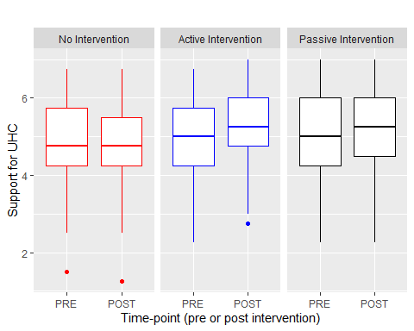

Boxplot showing effect of interventions on support for UHC

Descriptive statistics are summarized in table 2. Our data was analyzed using a 2x3 ANOVA with one within subjects factor (time of measurement, pre or post intervention) and one between subjects factor (experimental intervention type). Our main effect for our ‘passive’ intervention was not significant (p > .05) with our estimate being that participants in the passive intervention having greater support for UHC than those in the control condition. Our main effect for our ‘active’ intervention was also not significant (p > .05) with our estimate being that participants in the active intervention having greater support for UHC than those in the control condition as well.

There was a significant time x condition interaction. Participants only had an increase in support for UHC from pre to post measure when they were assigned to one of the two intervention conditions, specifically the interaction between being assigned to our passive intervention, and the post-intervention measure of support for UHC (p = 0.095).

Looking at our graph, we see in our box and whisker plot, that there does seem to be a trend towards increased scores on support for UHC from the pre to the post for our two experimental interventions. Just as importantly, we also see a strong lack of change from pre to post intervention support for UHC in our control condition.

Lastly, we did an independent samples t-test to determine if there was any difference in our two intervention groups regarding willingness to use the selected plan for themselves. Both groups were relatively willing to use the selected plan for themselves, but there was no difference between the two intervention groups on the amount of willingness.

## Qualitative Results

We used very naive analysis for our qualitative response section, simply looking at our responses and examining them to see if any trends existed. We found that participants occasionally had difficulty understanding the instructions. Several occasions occurred where the participant asked the administrator how to complete the exercise, after being exposed to the instructions. Some examples of these responses:

“Confusing without instructor help”

“The way that plan was laid out with the pegs was slightly confusing and I think that it might provide more accurate answers if it were formatted more clearly. Otherwise, I thought that the different levels of care were described well and gave a good picture of what would be provided.”

Additionally, several participants found this exercise particularly interesting, engaging, fun, and helpful. The purpose of both interventions was to increase engagement with the often-times complex material inherent in UHC. These responses were at least some indication that our interventions were fulfilling those goals. Some examples of these responses:

“I liked the exercise and I thought it was cool to see all the different types of health plans people can choose from.”

“It gives you perspective on how hard it is to choose what plans cover what. It makes you think twice about criticizing health plans and those who come up with in.”

“I thought that the exercise was effective in making me evaluate the perks and downsides of different health care plans.”

Taken all together, we found that improving our instructions and potentially clarifying or simplifying the task was important before implementation of our second study. However, given the positive feedback in the free-response section were were confident that this was likely an effective route of communication with our subjects.

## Summary of Pilot Study Results

Using frequentist methods, we found no statistically evidence at an $α$ of 0.05 confirming our initial hypotheses. There was an interaction that trended towards statistical significance between our time measure and our intervention condition, which provides some support for our first hypothesis. Using Bayesian modeling, we found weak evidence supporting our first hypothesis, given a large range of uncertainty in our point estimates of support per condition. Lastly, our simple two-sample t-test found no difference between our two intervention conditions, B and C, when seeing which group would accept/reject the proposed health benefit plan for themselves.

# Study 2

As a follow-up to study one, study two directly addresses the initial concerns indicated in our previous research. One concern that arose while running our experiment was that our control condition did not contribute any external validity. Because of this, we chose to change our ‘control’ condition in our planned study to more closely reflect ‘standard’ UHC messaging that subjects would see in the world around them, instead of a uninformative ‘dummy’ exercise.

Additionally, as previously mentioned, some subjects had trouble understanding our experimental materials and procedure. Improving our instructions and/or simplifying the task was necessary before implementation of study two. We resolved this concern by adapting our pen and paper exercise into an easy to use web applet.

Lastly, study one was predicated on the assumption that opposition and support for UHC hinged on both the need for equity and/or fairness, as well as having a system that is comprehendable and understandable. The CHAT intervention in the study was chosen as it directly addresses both of these issues. However, in study one, we did not directly measure these proposed mediating variables. Thus, in study two, we directly measured our two mediating variables in order to determine the validity of our proposed mediating mechanism.

# Method

## Participants

Participants were students enrolled in the Psychology 1000 course at a large midwestern university. Our study fulfilled 1 credit requirement for students in the course, of which students were required to obtain 7 credit hours. Participants were not given any other incentive for participation in the study. Randomization to different conditions was determined within the online survey software “Qualtrics,” used to deliver the pre and post test measures. Our total number of participants was 412. This study was advertised on the university credit hours tracking software alongside other qualifying studies, but received no other advertisement.

|  |  |  |  |
| --- | --- | --- | --- |
| **Characteristic** | **Control**, N = 195 | **Intervention**, N = 217 | **p-value** |
| **Age** | 18.68 (1.75) | 18.84 (2.08) | 0.3 |
| (Missing) | 1 | 2 |  |
| **Gender** |  |  | >0.9 |
| Female | 127 / (66%) | 146 / (68%) |  |
| Male | 64 / (33%) | 68 / (31%) |  |
| Gender Variant/Nonconforming | 2 / (1.0%) | 2 / (0.9%) |  |
| (Missing) | 2 | 1 |  |
| **Race** |  |  | >0.9 |
| White | 153 / (78%) | 161 / (74%) |  |
| Black | 14 / (7.2%) | 16 / (7.4%) |  |
| APAC | 7 / (3.6%) | 10 / (4.6%) |  |
| Other | 4 / (2.1%) | 7 / (3.2%) |  |
| White,Black | 3 / (1.5%) | 6 / (2.8%) |  |
| White,Hispanic/Latino | 2 / (1.0%) | 5 / (2.3%) |  |
| White,APAC | 3 / (1.5%) | 3 / (1.4%) |  |
| Hispanic/Latino | 2 / (1.0%) | 3 / (1.4%) |  |
| White,American Indian/Alaska Native | 2 / (1.0%) | 3 / (1.4%) |  |
| APAC,Hispanic/Latino | 1 / (0.5%) | 1 / (0.5%) |  |
| APAC,Other | 1 / (0.5%) | 0 / (0%) |  |
| Black,American Indian/Alaska Native | 0 / (0%) | 1 / (0.5%) |  |
| Black,Hispanic/Latino | 0 / (0%) | 1 / (0.5%) |  |
| White,Black,American Indian/Alaska Native,Hispanic/Latino,Other | 1 / (0.5%) | 0 / (0%) |  |
| White,Black,APAC | 1 / (0.5%) | 0 / (0%) |  |
| White,Other | 1 / (0.5%) | 0 / (0%) |  |
| **School Year** |  |  | **0.027** |
| Freshman | 152 / (78%) | 154 / (71%) |  |
| Sophmore | 24 / (12%) | 41 / (19%) |  |
| Junior | 11 / (5.6%) | 19 / (8.8%) |  |
| Senior | 7 / (3.6%) | 1 / (0.5%) |  |
| Other | 1 / (0.5%) | 2 / (0.9%) |  |

Table 3: Demographic Information of Subjects

## Measures

There are five main measures used for the primary study.

Our first three measures directly examine support for UHC and our two proposed mediating variables. The first is a 4 item measure of support for UHC, adapted from Shen & Labouff (2013) that is taken as a simple average, with the third item reverse scored. Each item was selected using a sliding scale that went from 0 (strongly disagree) to 100 (strongly agree). Cronbach’s alpha for the items in this measure was 0.85. The second is a single item measure of our equity/fairness mediating variable, adapted from Netemeyer, Boles, and McMurrian (1996), using a sliding scale that went from 0 (strongly disagree) to 100 (strongly agree). Our second measure was a 2 item measure of our understandability mediating variable, adapted from Mulken, Pair, and Forceville (2010). Both items were scored using a sliding scale that went from 0 (strongly disagree) to 100 (strongly agree), and the measure is a simple average of these, Cronbach’s alpha for the items in this measure was 0.92.

Our last two measures examined subjective and objective numeracy. Our subjective numeracy measure was the Subjective Numeracy Scale created by Fagerlin et al. (2007). This measure is a simple average consisting of eight items, with the seventh item reverse scored. Each item was selected using a likert scale that went from 1 (generally poor with numbers) to 7 (generally prefer numbers). The Cronbach’s alpha for these items is 0.84. An example item is: >“How good are you at calculating a 15% tip?”

The objective numeracy measure was the Rasch Numeracy Scale, created by Weller et al. (2013). This measure consists of 8 items, all math problems of varying complexity, generally using some amount of algebra, percentiles, and table reading skill. This measure was scored from 0 to 8, with the sum of all correct answers to the individual items as the subject’s objective numeracy score. The Cronbach’s alpha for these items is 0.71. An example item is: >“If it takes five machines 5 minutes to make five widgets, how long would it take 100 machines to make 100 widgets?”

Additionally, note that we did not initially collect data on subjective and objective numeracy until part-way through the data collection. Thus, the first 68 subjects do not have this data recorded.

## Materials and Procedure

Each participant begins clicking a link to the online survey software “Qualtrics,” which was used to distribute every element in our study. Our pre-test measure was then given, consisting of the support for UHC measure, perceived equity of UHC measure, and comprehensibility of UHC measure. After the pre-test measure, Qualtrics randomized our participants to either our intervention or control condition.

Participants in our intervention condition were directed to a web-exercise adapted from the Choosing Healthplans All Together (CHAT) paradigm developed by Danis, Biddle, and Dorr Goold (2002) . CHAT consists of participants designing their own Universal Health Care plan by trading off limited “points.” Most groups of medical care are represented, costing different amounts of points. Some care options also had greater levels of intensity offered for correspondingly higher amounts of points. As compared to study one, the web-exercise for our intervention condition requires no mathematical calculation and is much simpler to administer. Participants in our control condition were directed to ‘traditional’ messaging on the benefits of UHC, as presented from trusted sources including the World Bank and the World Health Organization. For either condition, the subjects are asked to consider how the universal health care would affect their own lives.

Afterwards, participants received a post-test measure, consisting of three main sections. The first is the mostly the same as our pre-test section (support for UHC, perception of UHC equality, understanding of UHC). There are additional items inquiring as to whether or not individuals pay for their own health insurance, or if they have been uninsured, and the intervention condition was asked if they would be happy having the plan they built as their own health insurance. The second section is a simple free-response question asking about the subjects thoughts about the exercise they just completed. The third section is demographic information, including sex, age, and current year of schooling.

Finally, our participants read a one page paper debriefing them of the purpose and theory behind the research, and was then granted 1 credit in the Psych 1000 system. This entire process takes 20-25 minutes on average.

## Design

The design of this experiment is a multi-level model. The multi-level structure consisted of UHC measures (either pre or post intervention), nested within each subject. The experiment was thus a 2x2 between subjects design. While our time variable (pre or post intervention) is ‘within’ our subjects, any given subject will only be exposed to one of the experimental conditions, thus it is ‘between’ subjects. The first ‘2’ is our independent variables of time of measurement (pre or post intervention), the second ‘2’ is our two experimental conditions, the control and the intervention. Our primary dependent variable was support for UHC, with two mediating variables on comprehensibility and equity. Additionally, we also measured subjective and objective numeracy. I believe that there should be no other extraneous variables that might influence our results.

# Results

## Quantitative Results

A total of 412 subjects completed our exercise. Our final sample in our primary study included 195 participants in our control condition, and 217 participants in our intervention condition, and was approximately 67% female. Additional demographic information can be found in Table 3 above.

Table 4 presents the results of the primary analysis of our primary study, the effect of our intervention on support for UHC as modeled by a 2x2 multi-level model. Unexpectedly, we see that individuals in our control condition trended towards larger values than those in our intervention condition, the opposite of what we hypothesized.

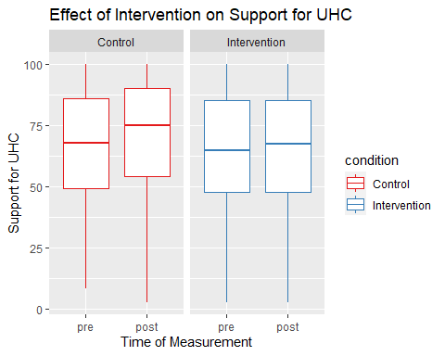

No significant main effect of intervention condition on support for UHC

## Mediational Effect of Understanding and Percieved Equity

Our secondary hypothesis was the existence of a mediational effect of understanding and perceived equity predicting increased support for UHC. The first element of our secondary hypothesis can be seen in table 5. We clearly see in this table that there seems to be a statistically significant effect wherein increased understanding predicts increased support for UHC. Additionally, while accounting for the effect of both understanding and our intervention, we see that there is a statistically significant effect of both understanding, and our intervention. However, while understanding has increased in both groups from our pre-measurement to our post-measurement, there is no statistically significant difference in the increase in understanding across both groups. Thus, given the lack of difference in the increase in understanding scores across the two conditions, we can conclude that there likely is not a mediating effect of understanding on the increase in UHC support from our intervention.

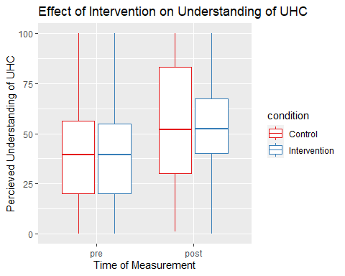

Condition does not have significant effect on Understanding

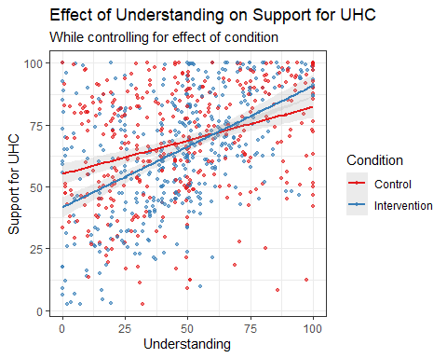

No significant difference in effect of understanding on support for UHC across conditions

The second element of our secondary hypothesis can be seen in table 6. We clearly see in this table that there seems to be a statistically significant effect wherein an increase in perceived equity predicts increased support for UHC. Additionally, while accounting for the effect of both perceived equity and our intervention, we see that there is a statistically significant effect of both understanding, and our intervention. Furthermore, perceived equity has increased only in our control group, and not in our intervention. There is a statistically difference in the increase in perceived equity across both groups. Thus, given the difference in the increase in perceived equity across the two conditions, we can conclude that there likely is a mediating effect of understanding on the increase in UHC support from our intervention.

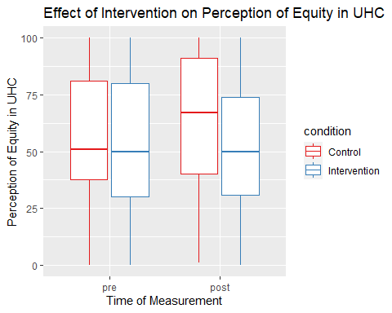

Condition has significant effect on Percieved Equity

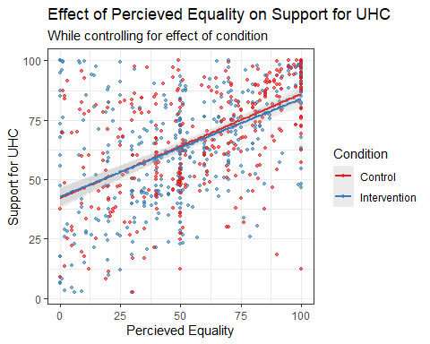

No significant difference in effect of percieved equity on support for UHC across conditions

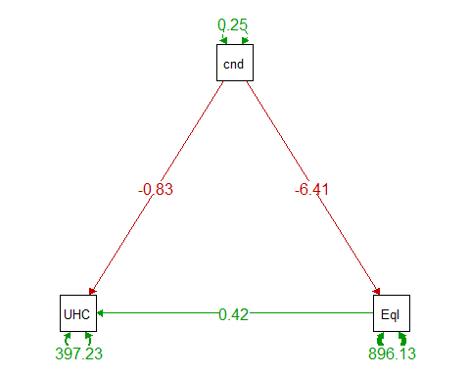

Path Diagram showing the effect of condition on UHC Support and Percieved Equity

We choose to parameterize our proposed mediational relationship using a path diagram, as seen in figure 7. This directly accounts for the effects of our measure of UHC being predicted by both perceived equality and experimental condition, as well as our measure of perceived equality being directly predicted only by our experimental condition. We see that there is a mediational relationship between condition and UHC through the effect of perceived equity. Increased perceived equity increases support for UHC, and the control condition both has greater support for UHC, as well as greater perceived equity. Thus, this path diagram indicates what we believe to be a mediational relationship.

## Moderating Effect of Numeracy

Our final hypothesis was whether or not there was a moderating effect of numeracy on increased support for UHC. We examined both subjective numeracy, as well as objective numeracy, in relation to our intervention condition.

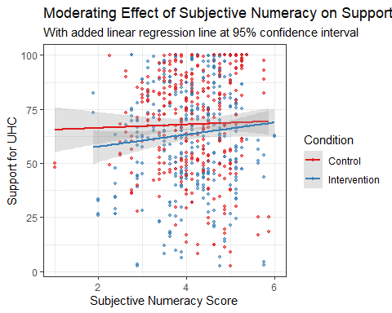

Subjective numeracy effect not significant in intervention

Looking at the effect of subjective numeracy on support for UHC in table 7, we see that there is no significant interaction, or even direct effect, of subjective numeracy on support for UHC. Given the lack of direct effect and interaction, we can safely conclude that there is no moderating effect of subjective numeracy on support for UHC.

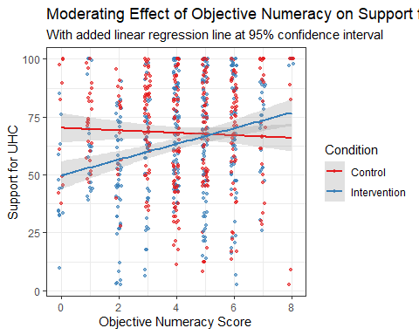

Objective numeracy effect significant in intervention

Comparatively, looking at our effect of objective numeracy on support for UHC in table 8, we see completely different results. Firstly, there does indeed seem to be a direct effect of objective numeracy on support for UHC, wherein increased objective numeracy predicts greater support for UHC. Additionally, we see that there is a significant interaction between the effect of objective numeracy and the condition. Examining the graph above, it is very clear that there is a significant effect of objective numeracy on support for UHC primarily driven by the strong effect of objective numeracy in interaction with our intervention condition.

## Qualitative Results

In addition to our statistical modeling work on our quantitative data, we did some preliminary naive text analysis on our free-response section.

Primarily, our responses fell into 3 rough categories. The first, the difficulty category, contained responses that conveyed a belief that the exercise was difficult, hard to complete, or otherwise problematic. In our intervention condition, 23% of our free responses were categorized in this way. In our control condition, 0% of our responses were categorized in this way. Some examples of this category of responses:

“it was much more difficult than I thought it was going to be; I had to compromise points in some places to be able to get at least basic coverage in other areas”

“It’s hard for me to think about people having to pick and choose which parts of healthcare they’ll have access to when they’re all important. It makes me wish healthcare would be reformed for the good of everyone and not just those who can afford it.”

Our second category were responses that conveyed a belief that the exercise was interesting, engaging, or “eye-opening.” 49.8% of our responses in the intervention condition, and 53.2% of our responses in our control condition were categorized in this way. An example of these responses:

“Interesting that my answers changed. I would be interested in seeing someone against Universal Health Care make a study, too.”

Our final category were responses that conveyed the perception that this exercise was enjoyable, worked well, or convinced them to support UHC. 18.4% of the responses in our Intervention, and 8.7% of our responses in our control condition were categorized. An example is:

“Enjoyed it, overall I believe that there should be Universal Health Care, but I did not realize how complicated it was. This exercise showed me how complicated it will be if the US decides to go through with something like this.”

# Discussion

## Relate Results to Past Research

Given the pre-existing literature, as well as our results from study one, we expected a strong effect confirming our hypothesis. However, we did not find a statistically significant main effect of our intervention in our primary study from the perspective of a 2x2 multi-level model.

Keeping in track with previous research, we did find that overall there was a reasonable level of support for UHC as the majority (69% of our subjects) of our participants found the plan acceptable. We also replicated the generally positive level of support found by Huebner et al. (2006), but in a non-medical student population. We replicated the findings of Danis, Biddle & Goold that the majority of individuals exposed to a health benefit package would be willing to use the health package for themselves.

Furthermore, our results were different from Weiger, Armstrong & Shaffer, 2019. In study two, we were interested in seeing if our results from study one replicated. Specifically, we wanted further confirmation on whether or not an experiential intervention would be more effective than an informational intervention. Compared to study one, while we did not have two interventions, our control condition was a pseudo ‘information only intervention,’ as it was presenting commonly accepted facts about UHC from well trusted sources. Given that support for UHC was higher in our information only based control condition than it was in our experiential intervention, we replicated our earlier results indicating that to be the case from study one.

Interestingly, there was significant evidence supporting our secondary hypothesis. When directly measuring our proposed mediating variables, we see that both perceived equality as well as understanding of UHC strongly predicted support for UHC. Furthermore, our mediating variables indicated that while our control condition increased both perceived equality as well as increased understanding, our intervention condition only increased understanding. Indeed, after conducting a mediational analysis, we could plausibly conclude that since there was an effect of condition on perceived equity, and since we did see a difference in support for UHC across conditions, that this mediational relationship was the mechanism by which our difference in support manifested. Lastly, while we did see an increase in variance in perceptions of equality between our control and intervention, the difference was not statistically significant, and the group mean of both conditions was extremely similar.

The effect of numeracy on support for UHC was quite unexpected. Firstly, we had assumed that both objective and subjective numeracy would have similar effects, if any effect was extant at all. Secondly, we had assumed that the effect of numeracy would be the same across both categories. Neither of these two assumptions was correct. We saw very clearly in table 5 that there was a significant effect of objective, not subjective numeracy. Also, the impact of objective numeracy was significantly greater in our intervention than in our control. Considering the impact of objective and subjective numeracy, it is fairly obvious that our intervention skill required some larger amount of comfort with numbers, given that the core of the exercise was trading off various health benefits using a limited pool of resources. However, while study 1 initially required manual calculation with physical calculators, the web-exercise that was designed for study 2 was constructed such as to minimize required calculations. Perhaps one reasonable supposition is that without sufficiently great objective numeracy, it was difficult for an exercise primarily centered on numbers to be effective. An alternative supposition would be that highly numerate individuals were significantly more engaged with an exercise that let them use their numeracy, leading to more attention paid, resulting in a larger effect of our intervention.

With regards to our qualitative data, we saw a significant difference in the proportion of types of content in both intervention and control condition. Unsurprisingly, no individuals in our control condition had any difficulty with the very simple exercise (reading multiple fliers). In comparison, after reading the responses, it seemed very clear that the main source of difficulty for individuals in the intervention condition was ‘agonizing’ over the optimal distribution of resources so as to have the most preferred health plan. Conceptually, this seems more like a feature than a bug. Confronting individuals with a realistic and difficult choice similar to those for health-care policy officials is exactly the purpose of the exercise. Additionally, over double the number of individuals in our intervention condition expressed active support and appreciation for the purpose of the exercise, that it improved their understanding of the problem and that it was a fun and enjoyable exercise.

However, one consistent category of responses across both conditions were subjects that believed that the exercise was either politically motivated, or had a strong intentional bias in it’s construction. This lead to some subjects expressing suspicion or lack of belief in the presented information. Perhaps a reasonable extension would be to present HBP for a UHC in comparison to a set of standard private insurance plans. Additionally, it would be interesting to see how much this correlates with or against political affiliation, which was not measured in the primary study.

## Limitations

Study one and two both recruited participants from a large midwestern university located in a medium sized midwestern city. This is not necessarily reflective of the majority of the insurance buying population, or those individuals able to effect change on UHC. The design of study two required a reasonable amount of familiarity with internet and online survey platform technology, which may make it difficult to adapt to older or less tech-savvy populations. Some subjects indicated in the free-response section that the information presented was biased towards support for UHC and did not paint the whole picture of arguments supporting our current private care system. Therefore, we were unable to derive potential insights comparing to see if positive messaging on private health care would reduce support for UHC.

## Future Directions

There are a great deal of interesting and clearly worthwhile directions to use moving forward. The lowest-hanging fruit would be to execute a replication of the study, providing further evidence of our proposed mediating relationship and moderating effects, on a group that more closely mimics the insurance buying public. Perhaps this could be done through Amazon’s mechanical turk, or through another recruitment avenue. This would provide additional external validity to the study, as the primary decision-makers around health insurance are not university students. Something that would also be very simple for any replications or pseudo-replications of this research moving forward, would be to develop a structured plan for qualitative analysis. A potential avenue would be to use various forms of semantic text analysis, LIWC specifically.

Additionally, there are several modifications of the experimental materials that would be of interest to examine. Primary in my thoughts is to determine if our current allotment of resources would have greater or lesser support as compared to our current allotment of 49 units out of 79 potential units. If there is no significant difference in either greater or lesser amounts, that would perhaps provide evidence indicating that the structure of the UHC as presented through a HBP is has greater salience in determining approval versus simply the objective healthcare options available.

There are other additional measures that would be worthwhile to measure as well, to see if there is any moderating effects. Our naive qualitative analysis indicated that many participants were skeptical of a potential political agenda from the researchers, or were otherwise concerned about the ‘neutrality’ or ‘objectivity’ of our material. This would be something we could examine by measuring political orientation and polarization. Related to our previous point, we could also design experimental material that explicitly promotes ‘standard’ private health insurance as it exists in the USA, or compare to negative messaging on ‘standard’ private health care without having positive information about UHC. Lastly, if we could find some way of measuring actual equity of a given plan, and to see if different distributions of elements in a plan (actual equity) has similar effects to perceived equity of UHC.

Lastly, I believe that the main thing of value to explore next would be to determine to see if there is some execution of the HBP that would be similarly effective to our current one, with individuals that have lower objective numeracy. Low objective numeracy is fairly common in the US population, and having an intervention that does indeed work to increase support for UHC only in individuals with high-objective numeracy is definitionally a problem with regards to the scope of the population that we wish to influence. Some considerations would be perhaps be a simplified version of the exercise, or to clearly indicate the trade-offs using a computer activity that doesn’t explicitly reference numbers or calculation.

# References

Assembly, The General. 1991. “UN general assembly resolution 44/225.” *Marine Policy* 15 (5): 331–32. <https://doi.org/10.1016/0308-597x(91)90085-p>.

Chalkidou, Kalipso, Patricio Marquez, Preet K Dhillon, Yot Teerawattananon, Thunyarat Anothaisintawee, Carlos Augusto Grabois Gadelha, and Richard Sullivan. 2014. “Evidence-informed frameworks for cost-effective cancer care and prevention in low, middle, and high-income countries.” *The Lancet Oncology* 15 (3): e119—–e131. <https://doi.org/10.1016/S1470-2045(13)70547-3>.

Danis, Marion, Andrea K. Biddle, and Susan Dorr Goold. 2002. “Insurance benefit preferences of the low-income uninsured.” *Journal of General Internal Medicine* 17 (2): 125–33. <https://doi.org/10.1046/j.1525-1497.2002.10609.x>.

Danis, Marion, Andrea K. Biddle, and Susan Dorr Goold. 2004. “Enrollees Choose Priorities for Medicare.” *Gerontologist* 44 (1): 58–67. <https://doi.org/10.1093/geront/44.1.58>.

Fagerlin, Angela, Brian J. Zikmund-Fisher, Peter A. Ubel, Aleksandra Jankovic, Holly A. Derry, and Dylan M. Smith. 2007. “Measuring numeracy without a math test: Development of the subjective numeracy scale.” *Medical Decision Making* 27 (5): 672–80. <https://doi.org/10.1177/0272989X07304449>.

Galvani, Alison P, David P Durham, Sten H Vermund, and Meagan C Fitzpatrick. 2017. “California Universal Health Care: An economic stimulus and lifesaving proposal.” *The Lancet* 390 (10106): 2012–14. <https://doi.org/10.1016/S0140-6736(17)32148-7.California>.

Glassman, Amanda, Ursula Giedion, Yuna Sakuma, and Peter C. Smith. 2016. “Defining a health benefits package: What are the necessary processes?” *Health Systems and Reform* 2 (1): 39–50. <https://doi.org/10.1080/23288604.2016.1124171>.

Goold, Susan Dorr, Andrea K. Biddle, Glenn Klipp, and Marion Danis. 2005. “Choosing healthplans all together: A deliberative exercise for allocating limited health care resources.” *Journal of Health Politics, Policy and Law* 30 (4): 563–601. <https://doi.org/10.1215/03616878-30-4-563>.

Huebner, Jeffrey, Jaya R Agrawal, Ashwini R Sehgal, Paul Jung, Joan Hedgecock, and Steven R Simon. 2006. “Universal health care and reform of the health care system: Views of medical students in the United States.” *Academic Medicine* 81 (8): 721–27. <https://doi.org/10.1097/00001888-200608000-00008>.

Hurst, Samia A., Mélinée Schindler, Susan D. Goold, and Marion Danis. 2018. “Swiss-CHAT: Citizens discuss priorities for Swiss health insurance coverage.” *International Journal of Health Policy and Management* 7 (8): 746–54. <https://doi.org/10.15171/ijhpm.2018.15>.

Manchikanti, Laxmaiah, Frank J. E. E Falco, Mark V. Boswell, and Joshua A. Hirsch. 2010. “Facts, fallacies, and politics of comparative effectiveness research: Part 2 - Implications for interventional pain management.” *Pain Physician* 13 (1): 55–80.

Manchikanti, Laxmaiah, Vijay Singh, Sukdeb Datta, Steven P. Cohen, and Joshua A. Hirsch. 2009. “Comprehensive review of epidemiology, scope, and impact of spinal pain.” *Pain Physician* 12 (4): 35–70.

Mulken, Margot van, Rob le Pair, and Charles Forceville. 2010. “The impact of perceived complexity, deviation and comprehension on the appreciation of visual metaphor in advertising across three European countries.” *Journal of Pragmatics* 42 (12): 3418–30. <https://doi.org/10.1016/j.pragma.2010.04.030>.

Netemeyer, Richard G., James S. Boles, and Robert McMurrian. 1996. “Development and validation of work-family conflict and family-work conflict scales.” *Journal of Applied Psychology* 81 (4): 400–410. <https://doi.org/10.1037/0021-9010.81.4.400>.

Panpiemras, Jirawat, Thitima Puttitanun, Krislert Samphantharak, and Kannika Thampanishvong. 2011. “Impact of Universal Health Care Coverage on patient demand for health care services in Thailand.” *Health Policy* 103 (2-3): 228–35. <https://doi.org/10.1016/j.healthpol.2011.08.008>.

Shen, Megan Johnson, and Jordan P. Labouff. 2016. “More than political ideology: Subtle racial prejudice as a predictor of opposition to universal health care among U.S. Citizens.” *Journal of Social and Political Psychology* 4 (2): 493–520. <https://doi.org/10.5964/jspp.v4i2.245>.

Summers, Lawrence H. 2015. “Economists’ declaration on universal health coverage.” *The Lancet* 386 (10008): 2112–13. <https://doi.org/10.1016/S0140-6736(15)00242-1>.

Wegier, Pete, Bonnie A. Armstrong, and Victoria A. Shaffer. 2019. “Aiding Risk Information learning through Simulated Experience (ARISE): A Comparison of the Communication of Screening Test Information in Explicit and Simulated Experience Formats.” *Medical Decision Making* 39 (3): 196–207. <https://doi.org/10.1177/0272989X19832882>.

Weller, Joshua A., Nathan F. Dieckmann, Martin Tusler, C. K. Mertz, William J. Burns, and Ellen Peters. 2013. “Development and Testing of an Abbreviated Numeracy Scale: A Rasch Analysis Approach.” *Journal of Behavioral Decision Making* 26 (2): 198–212. <https://doi.org/10.1002/bdm.1751>.